**i) TO FIND ROOT OF QUADRATIC EQUATION USING LABVIEW :**

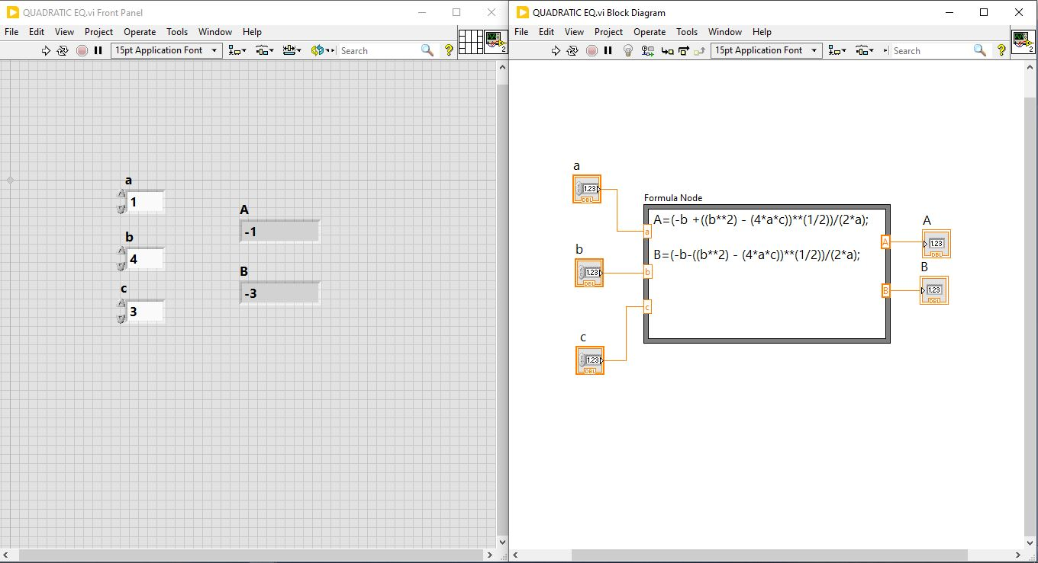

**ii) TO FIND BERTH OF TRAIN BY ENTERING SEAT NUMBER:**

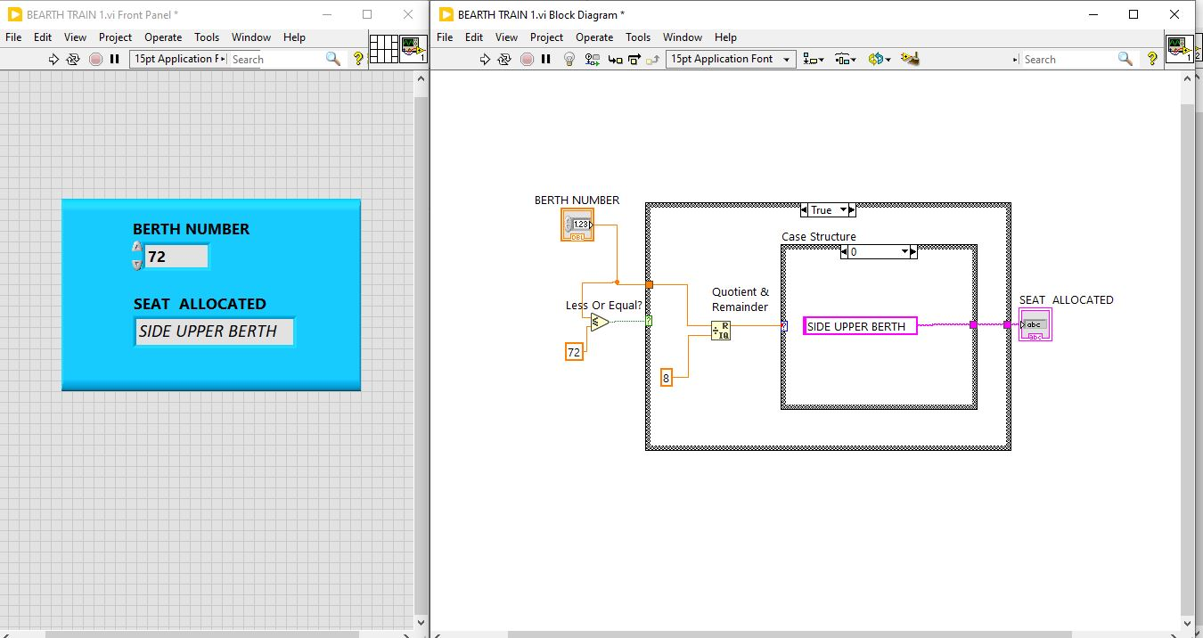

**iii) SEVEN SEGMENT DISPLAY USING LABVIEW:**

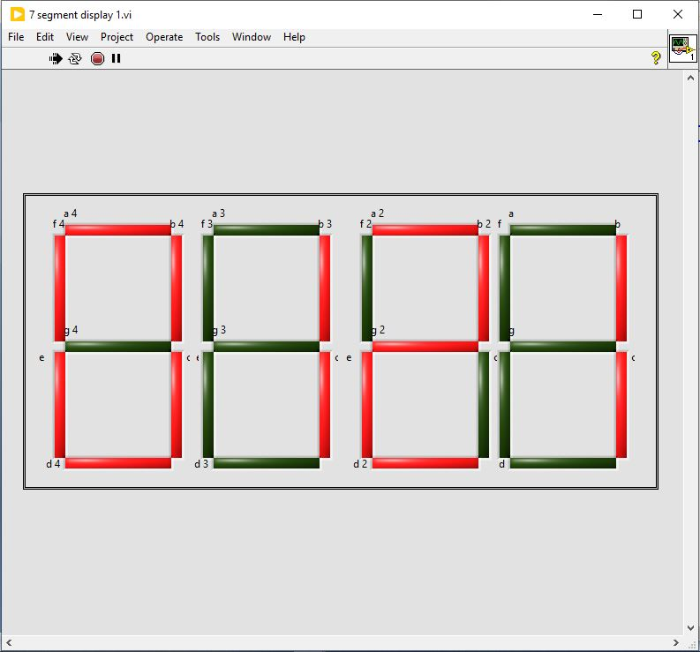

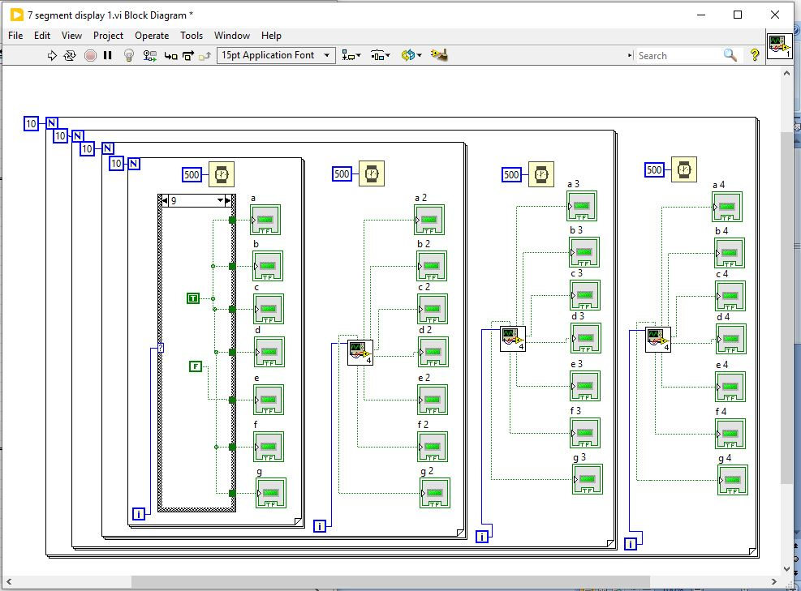

**iv) PASSWORD BASED SYSTEM LABVIEW:**

